CELEBRATING ERITREAN
WOMEN STARS

This March 8, International Women’s Day is unique for Eritreans, especially for Eritrean women who participated in the national liberation movement and women who have been involved in all spheres of nation building and in the empowerment of women within the national capacity building framework: our mothers (the core of our society or the mothers of the miracle makers and martyrs),Tegadelti (ex-liberation fighters), Hafash wedbat ( members of mass organizations). These women are always going to be remembered for their commitment, dedication and resilience.
It is known that since the liberation struggle for independence, the progressive leadership of the EPLF, encouraged women to participate based on the principle of “Equal Participation for Equal Rights.” Eritrean women from different social, economic and religious backgrounds joined the struggle in droves and fought for both the liberation of the Eritrean nation and for the emancipation of Eritrean women.
In the history of armed struggles, Eritrean women made a remarkable and unique history, thus adding their exceptional contributions to the uniqueness of the Eritrean liberation movement itself. In relatively comparable liberation movements such as that of Algeria Angola, Guinea Bissau, Mozambique, Nicaragua, Vietnam and Cuba, women were involved, yet the Eritrean women’s experience was extraordinary since Eritrean women tegadelti affirmed the praxis of the principle of “Equal Participation for Equal Rights” almost across all aspects of the movement. During the long and arduous 30 years war, tegadalit in par with her male comrade demonstrated her capacity, be it in hard combat or in taking a lead to taking initiative amidst insurmountable challenges.
Although Eritrean women have always been involved in all aspects of life within their society, during the national liberation struggle, the exemplary role of tegadalit set into motion notable progressive changes in the Eritrean women mindset and way of life. Women’s emancipation began in earnest and armed with rising socio/political consciousness, women started to challenge the traditional patriarchal ideology and to actively engage in all types of duties and responsibilities. The tegadalit got into active combat, from the trenches, mountains, across valleys and plains, she fought and died alongside her male comrades, and in several instances with unmatched resilience that one would only characterize as “tegadalitsque”.
The Eritrean liberation movement was unique, because unlike other movements which had the support from powerful nations, it was based on the principle of self reliance. In this case, self reliance wasn’t only in terms of material and finances, but also in terms of the comparatively limited human resources. Our mothers had to sacrifice their children for the national liberation struggle; typically, one household has at least offered two Martyrs! The Fallen Stars!
Eritrean mothers, often referred as Adetat, continued to endure the sacrifice of their children, yet again for the second time during the mercenary TPLF invasion. At that crucial do or die time, following in the footsteps of the thousands of heroines tegadelti, the young generation Warsays, were also martyred defending the nation alongside their male comrades. Once again, we paid precious lives. Fallen Stars!
Having all these shining stars in our heart, Eritrea and the resilient people of Eritrea continue to produce stars who reflect and bring to light the spirit of the Fallen Stars, wherever we reside. Following the spirit of these Fallen Stars, we continue to make possible the impossible. Short of making any conclusions, whether it emanates from nature or nurture or both, the “code” of boldness, bravery and resilience keeps passing on from generation to generation. The Fallen Stars are morphed into more vibrant Living Stars!
The Living Stars keep appearing and shining across the homeland and within the Diaspora communities; usually, with some measure of surprise. There are many stories of war heroine and heroes who literally defined nature and inspired their comrades by their bravery, despite their special need. A female star with similar limitations but in a different setting has appeared in an Ivy league graduation hall making history as the ERITREAN-American first deaf and blind Harvard Law school graduate. Haben Girma, as her first name implies is an inspiration for many individuals with special need. She made the impossible possible!
According to her interview, all her achievements could have not been possible without the support and encouragement of her Eritrean mother! a resilient mother! Haben has an extraordinary capacity to be able to defy all the odds. Haben is a pride to her family, to special need individuals and to Eritrea. https://www.theroot.com/eritrean-american-woman-became-1st-blind-deaf-graduate-1794859088)!
These days, looking for Eritrean female Living Stars in sports is not that hard to find. Last month, Eritrean female cyclists shone in the podiums of 2018 Africa Cycling Championships. Young generation female cyclists like Mosana Debesay, Wohazit Kidane, Bsrat G/Meskel and others) have been top in the Africa cycling media .http://www.ferwacy.rw/?eritrea-s-ghebremeskel-crowned-african-champion-of-female-cycling,
These young generation female success stories are the product of conducive environment facilitated by government policy of the post liberation era, dictated by the principle of “Equal Opportunity for Equal Rights”. Despite several challenges, the implementation of this policy has been playing a significant role in changing the status of women/girls across all sectors.
Live Stars like Mosana represents a shining example of success stories that female members of our society can achieve along their male counterparts. In fact, Mosana won a Gold medal as her older brother did. Mosana, as her name indicates gave Mosa for all Eritreans and of course, for the Fallen Stars!!! who fought along their brothers for liberation of the nation and for women’s emancipation! Credit should be given to Mosana’s parents, especially to her mother who encourages both her daughter and son to be equally successful in the field of their choice.
Then there appeared a Live Star lately introduced to the stories of our Fallen Stars, re-energized by the love and hospitality she received in the land of the people where her father called home. Tiffany Haddish shone in the stages of the Oscars sharing an inspiring discovery of her roots to the exclusive club of The US Film industry, donning traditional Eritrean clothing, Zuria. At one point, as Eritrean women do in various traditional ceremonies, she ululated and with that the name Eritrea, with love and also pride.
Tiffany’s life story, in some ways, may be a reference to outsiders who wonder about the resilient character of our people. The ERITREAN- American comedian has passed through a lot of challenges before she made it; and reached the stage to make a name for herself and also echo the Eritrean character in unexpected place and unexpected time. The spirit of making the impossible possible. https://qz.com/1221396/oscars-2018-tiffany-haddishs-eritrea-zuria-gown-and-eskista-dance-delights-eritreans/ .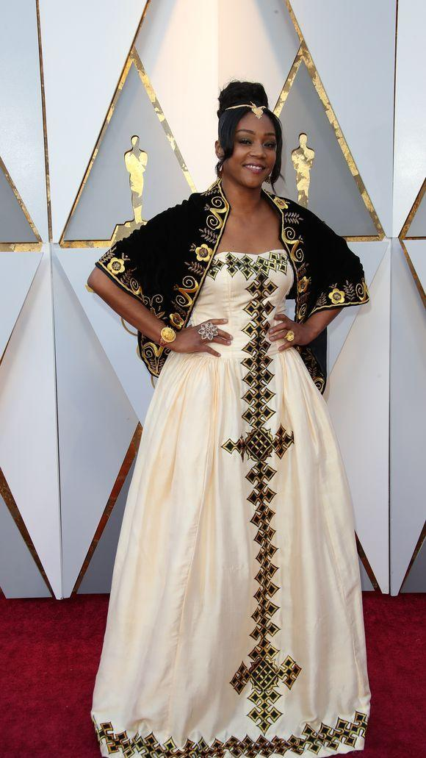

March 8, 2018 is very unique for one main reason; the emergence of Eritrean female achievers not only adds to the celebration of IWD, but it also signals that Eritrea is getting into a new stage where it will start to reap the fruits of its resilience and resourcefulness. There will be more pleasant surprises, not only in the forthcoming of new bright stars, but also in the termination of the long and hard game. Will March 8 next year be celebrated with more ululation past the moment after ‘THE GAME is OVER”.
Amuque Zkhri Nsematat
Awet Nhafash!

